

Division of Information Technology & Sciences
Department of Computer & Digital Forensics
Mobile Forensics

Mobile Forensics Lab

Android Investigation

Objective:
The lab consists of seven tasks.

Notes:
- You are required to provide screenshots of any step that you have performed during the Lab. Screenshots should clearly show any step used and its results. This could be done using a tool such as the “Snip and Sketch” tool, to highlight your work.
- A thorough explanation and analysis are required to demonstrate your understanding of all steps that you performed.

Task #1: Creating the device (Optional)
In order to investigate a populated device, we must properly create the device first. Here we will cover how to properly create an android device in Android Studio with proper access to ensure a full forensic recovery is possible.

Something that must be noted when creating a device for data generation, is that you can ensure that you can establish proper access to the devices filesystem. This is so you can image the device and pull the full filesystem, in essence, fully capturing all the relevant data that will fuel the investigation. Something that makes this easier is using older, more out of date technology which may have less protective measures.

In this case, we will be using the Pixel 3a XL, an older Pixel device that can run older Android generations. By keeping the device accessible, imaging will be easier for the investigator, and it will provide a good introduction to the forensic process on a mobile device.

We will be using Android Studio to create the virtual device on our local machines. The download for Android Studio can be found here.

In the case of this lab, this step is optional as an image is provided, but feel free to join us and understand what the background of creating these devices looks like.

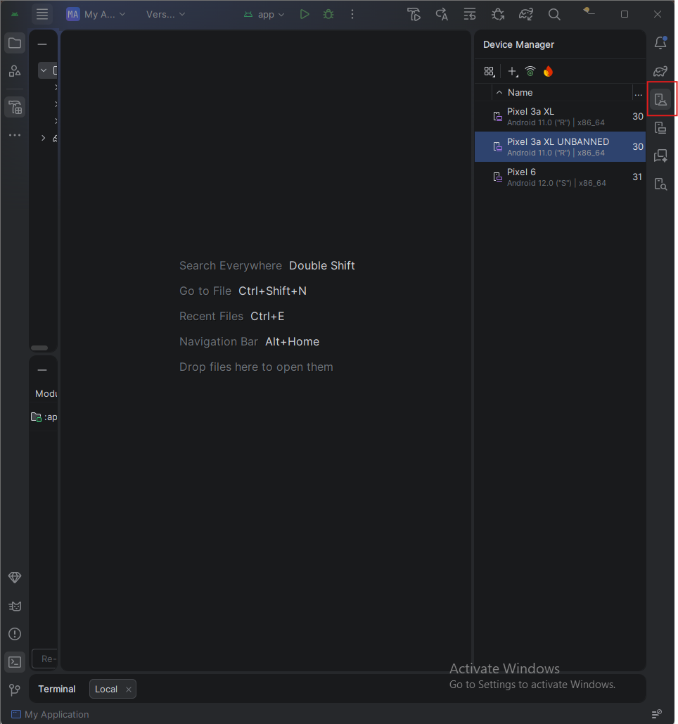
After installing Android Studio, your home page should look like this (minus the already created devices seen on the right). Outlined in red is the Device Manager, which will bring us to the next step.
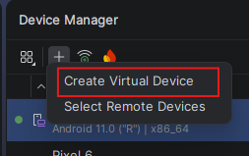
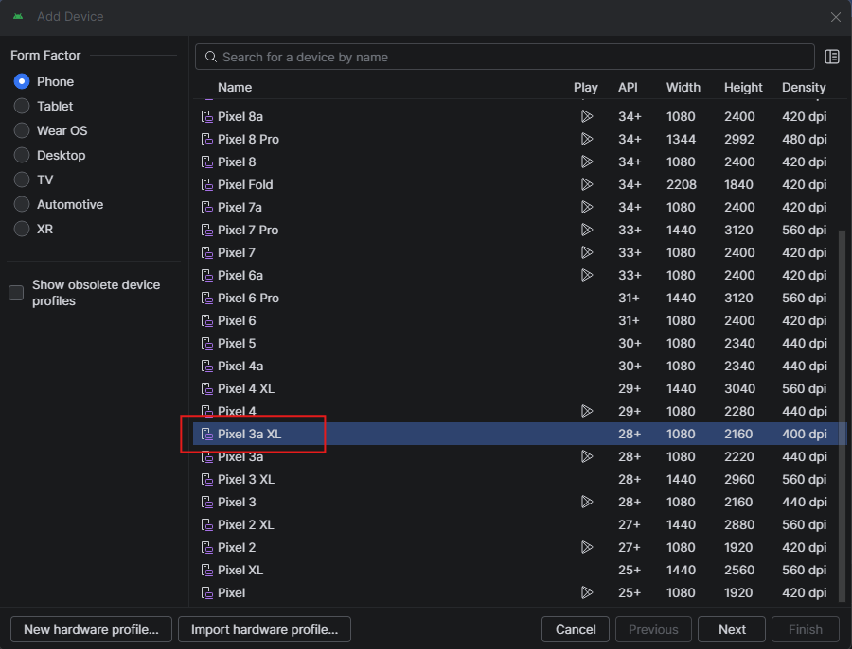
Next you will create your device and for the purposes of this lab we will be using the Pixel 3a XL. This device will allow for a seamless imaging of the filesystem.
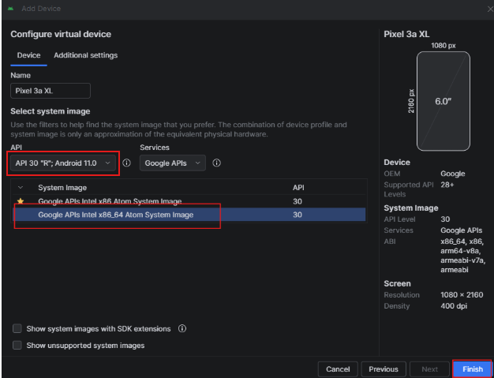
When configuring our device, we want to ensure that it is installed with API 30 “R”; Android 11.0. Additionally we want to install the x86_64 image for API 30. This will ensure that our installed applications can interact with the device, leaving the proper databases and files. Outdated devices can lose compatibility with modern applications so it is important to recognize if support is still offered for the desired application compared to your device's configuration.
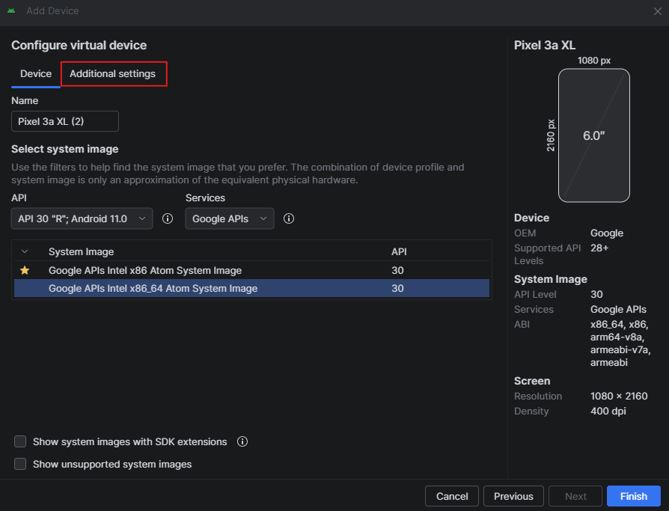
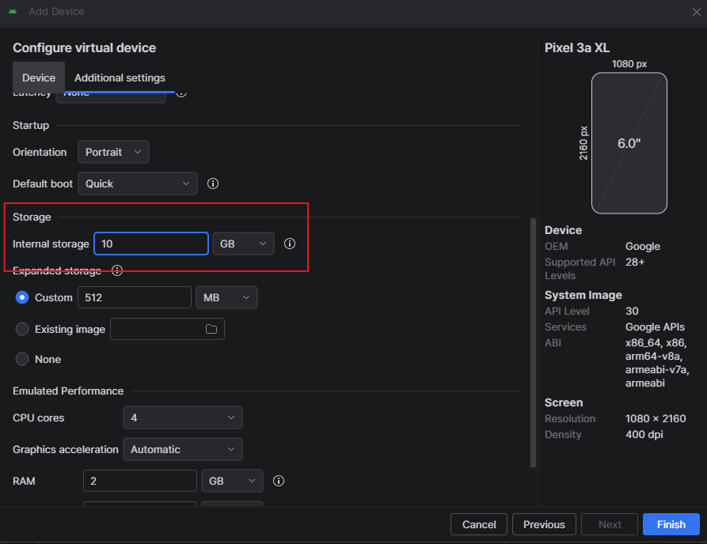
Next, go to additional settings and increase the size of the device so we can guarantee there will be no storage issues later down the road.
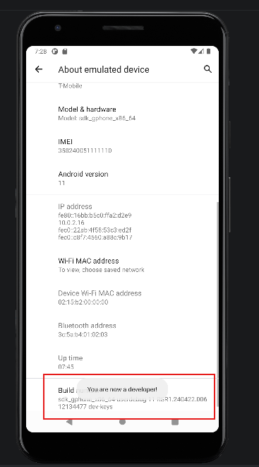
After opening the device, go to Settings → About emulated device → Build number, and click Build Number until it says “You are now a developer!”. This gives us elevated access within the device.

This investigation will take place on the set up devices but will also include data from Instagram. Because the device does not have access to the Google Play store, we will have to sideload the apk file which will install instagram directly into the filesystem

First begin by installing the 2 files for the instagram package here. Make sure that when you download the files, you move them into C:\Users\YOURUSER\AppData\Local\Android\Sdk\platform-tools. When the files are uploaded in there, open a fresh admin cmd.exe terminal in that same directory. If you are unfamiliar with how to do this, open cmd.exe, and run the command cd C:\Users\YOURUSER\AppData\Local\Android\Sdk\platform-tools. You will then be in the correct directory.

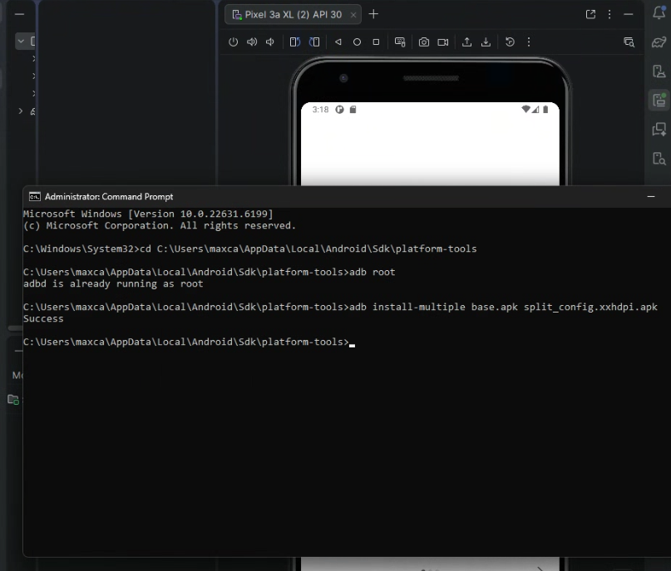
With the device turned on, run the command, adb root to ensure that you have root access to your device. In my case, I already had root access, but once this is established, then you can download your apk. Now run the command adb install-multiple base.apk split_config.xxhdpi.apk. From there Instagram should be installed properly and awaiting a login.
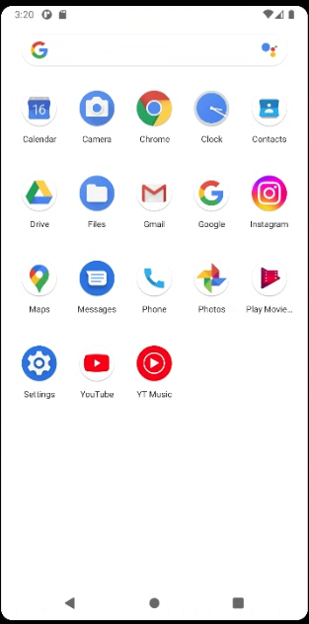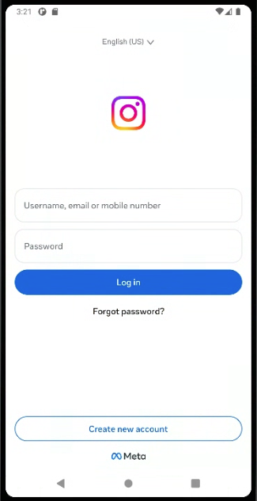

Now our device is ready to begin data generation.

Task #2: Imaging the Device
Now that whatever data gen you have chosen to do on the machine is done, we must image the device by pulling the full filesystem. Pulling the filesystem will provide us with a forensic image of the filesystem, allowing us to investigate the device in a stagnant form. This assures that no data is modified during the investigation and all files/databases stay the same.
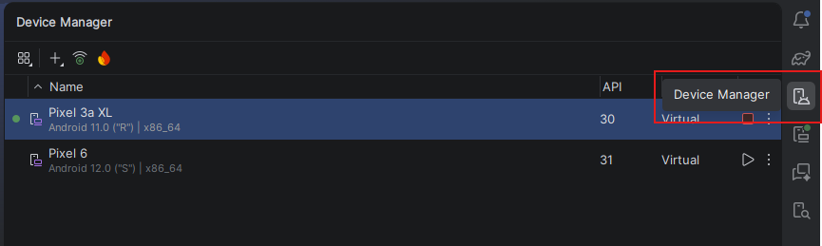
The first step is ensuring that our targeted device is powered on so we can run adb commands on the device
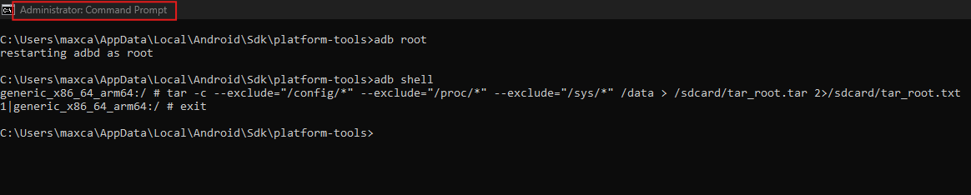
Open another cmd.exe terminal and change your directory to C:\Users\YOURUSER\AppData\Local\Android\Sdk\platform-tools. After changing your directory with the cd command, make sure you are operating with a root shell by executing adb root. Once that is done, we must generate the compressed file of our /data directory where the phone's main contents are stored. We can do this by entering the root shell with adb shell and then entering the command tar -c --exclude=”/config/” --exclude=”/proc/” --exclude=”/sys/*” /data > /sdcard/tar_root.tar 2>/sdcard/tar_root.txt.

That command was a lot of text so lets break it down:
- tar -c
  - This begins the process of gathering a selected directory and creating a .tar file which is an uncompressed bundle of files. This is similar to a zip file, just not compressed, it gathers a bunch of files and directories into one file, called a tarball. The reason this was chosen in this case was to reduce image size and overall processing time. We will still get all the relevant artifacts, just with a little less fluff.
- --exclude=”/config/” --exclude=”/proc/” --exclude=”/sys/*”
  - These directories can carry some irrelevant information that is not pertinent to a static investigation. These directories carry information such as hardware configuration, power status, and other runtime information. The reason these are excluded is because they either are not relevant, the volatility of the data can compromise its ability to be written, or it will not be properly handled into the tar file, making it forensically useless. These commands are not necessary but were done to limit image size and processing time.
- /data
  - This is the data source, the /data directory. In android filesystems /data captures the large majority of forensically relevant data. This is where the real meat is in your investigation so by targeting this directory, we are cutting out the outside noise, making it easier to hone in on relevant artifacts
- > /sdcard/tar_root.tar
  - This part makes sure that the /data directory is being processed into a tar file and is being written into tar_root.tar in the /sdcard directory. Because /sdcard is outside of /data, it is safe to write the image into, allowing us to pull the data later. The reason the data is not being sent to the machine, but rather inside the phone, is because android or linux filesystems have certain naming conventions that are not allowed on Windows machines. If you attempt to pull every file from the android device into your windows machine, there will be errors because of naming conventions. Windows devices however can handle tar files so this is the best way to generate the tar file while including all artifacts
- 2> /sdcard/tar_root.txt
  - This command redirects any errors into /sdcard/tar_root.txt. The 2> command reroutes any errors and sends it to the directed source. By putting it into a txt file, we can easily read and understand any errors that might occur if the tar file does not generate properly.

That was a lot! But now that we have our tar image of the androids filesystem, the next step is to pull that tarball out and process it.

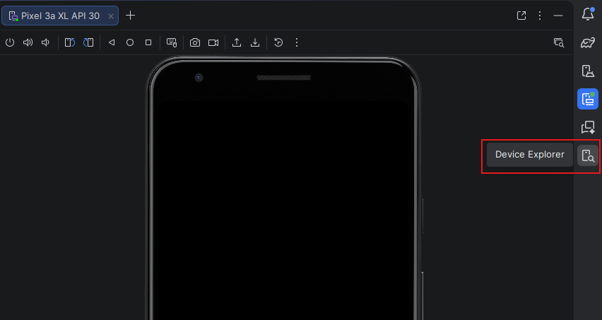
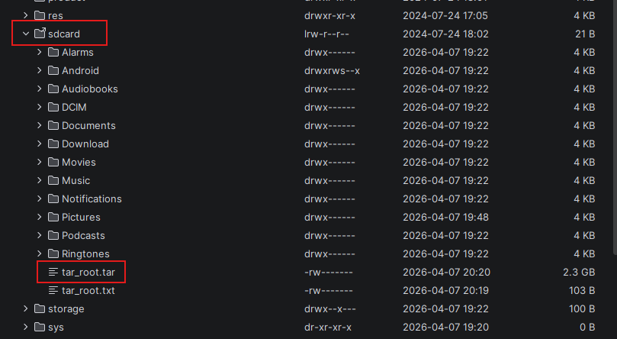
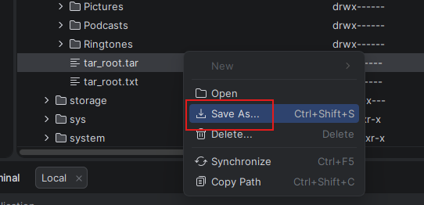
Now that the phones filesystem is fully pulled, make your way over to the Device Explorer tab which gives us access to the androids filesystem. Make your way down to /sdcard/tar_root.tar and press the Save As button to save the tarball onto your machine. Since we tarred the file inside the android, all the naming conventions should have been processed properly and are saved in the file, however Windows does not need to work with those files, just the tar file that contains them.

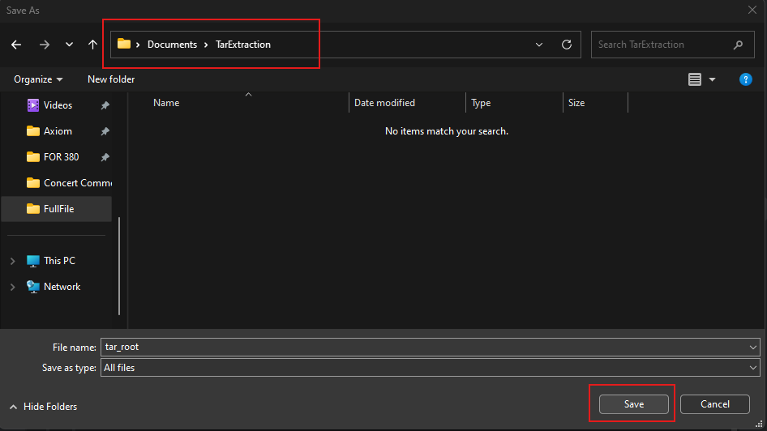
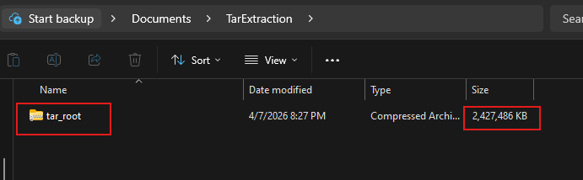
When it is saved, you should have something like this in your desired folder or directory. It should have the name you set in the tar command and have quite a large size. It does not need to be the exact size as my file because every device is different, however it should exceed at least 1GB.

Task #3: Processing the Device in AXIOM

Next we will move over to the popular digital forensics tool, Axiom Process, a tool that can parse all sorts of devices and pick apart relevant data inside their filesystems. It then organizes data by built in categories, allowing a more streamlined and straightforward investigation. Later in this report we will showcase the power of Axiom Examine, the program that works side by side with Axiom Process.

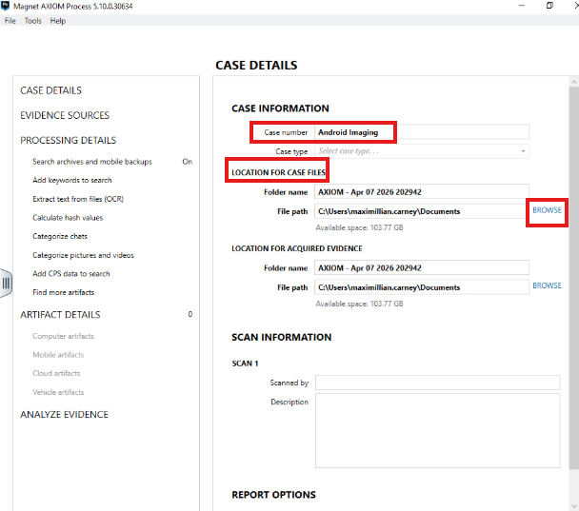
First you will want to name your case according to whatever naming convention you want to follow. For this example, we chose the name Android Imaging, but you can make it whatever name you please. Next choose an output location that Axiom will use to save your case files.
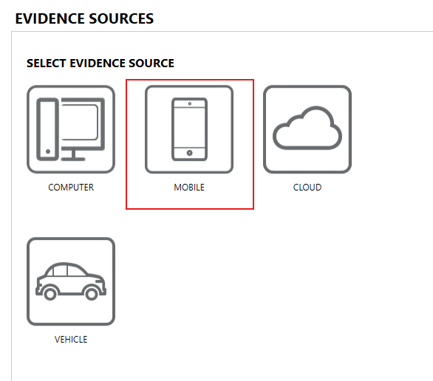
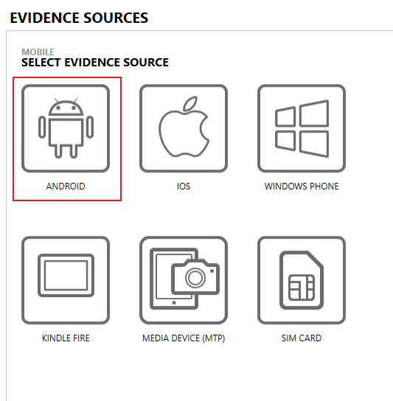
After hitting next, you will be prompted with a choice to choose your evidence source, here we used an Android Phone so choose Mobile → Android.
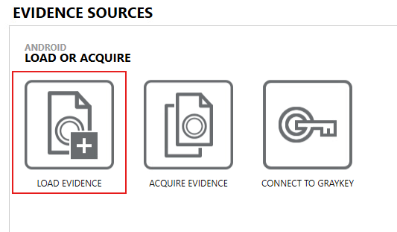
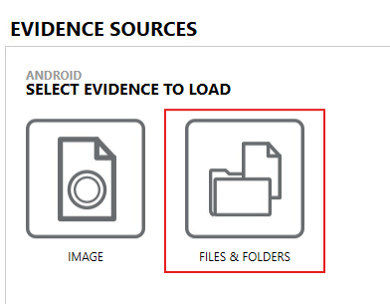
Next, we created a logical using tar, a service that bundles folders and files into one file. In Axiom’s terms, this is not a true forensic image because it does not meet the requirements like dd or E01, but it is rather a combination of folders and files. While tar was used to “image” the device, it really copied the filesystem, copying the files and folders that make up the android device, which is a logical image or a file level backup. This will still give us the information we need for an investigation while minimizing the resources required to create the files.
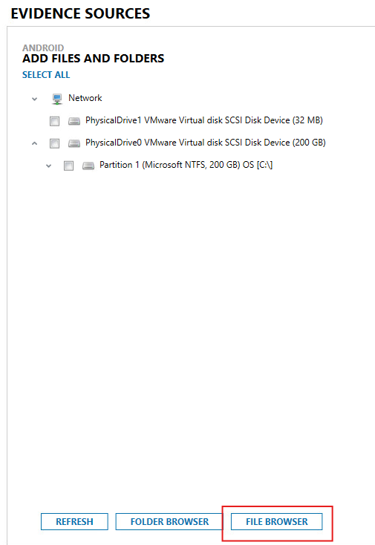
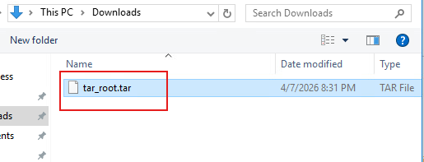
Now just find the tar file that you saved to your local device and upload it as a file for the evidence source. This is where Axiom will process all information from.
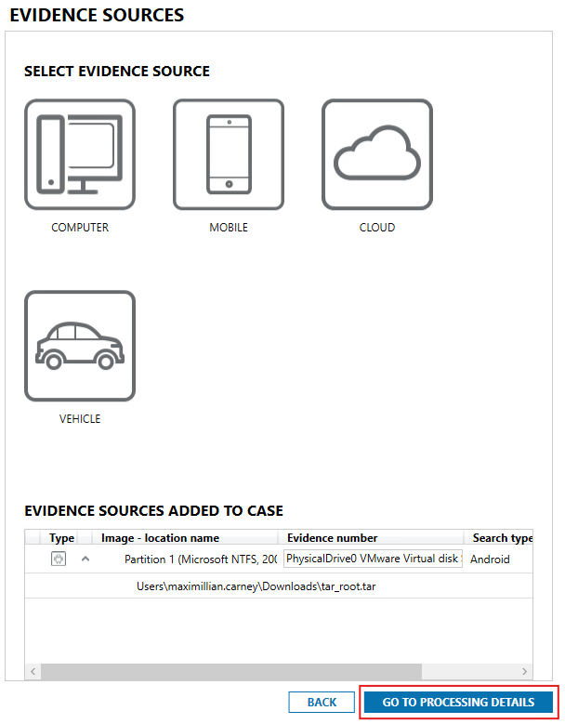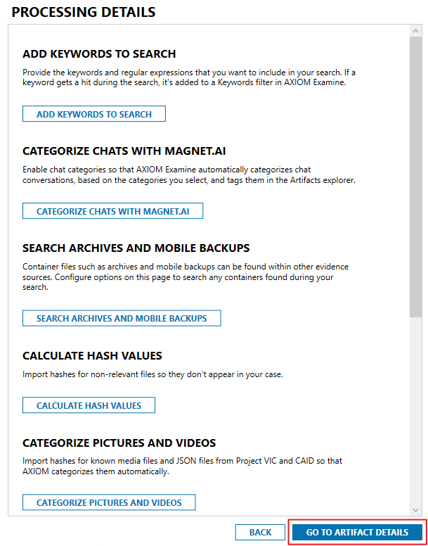
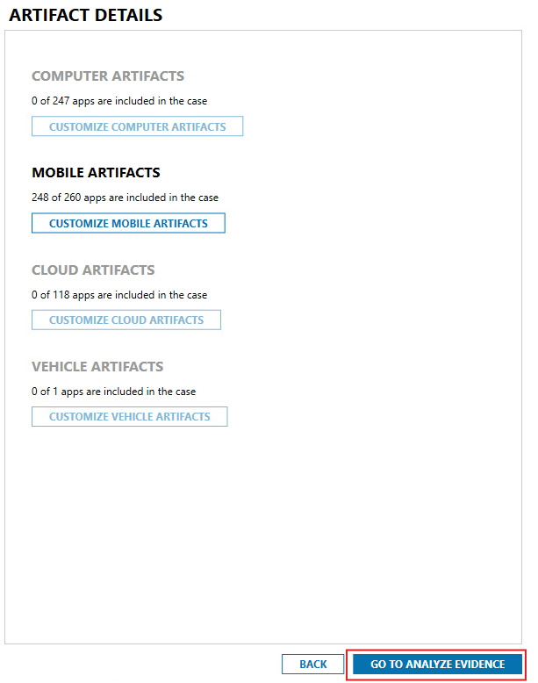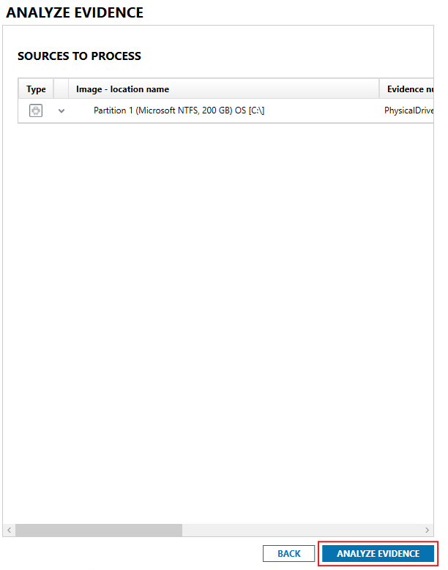
Next just keep clicking continue until you get to Analyze Evidence. This final button will begin the processing of the tar file from Axiom and will automatically launch Axiom Examine, the tool used to understand and filter through the parsed data. In Examine, files will be grouped in categories such as Operating System, Media, Communication, etc…, with relevant files going into each category. This relieves a lot of the stress on behalf of the investigator to parse and understand intricate or hard to find databases.

Task #4: Processing the Device in ALEAPP
Considering we covered how to process the case in AXIOM, we should also cover a free, open source tool, ALEAPP. This tool has a lot of the same functionality as AXIOM examine, albeit less powerful, the advantages are that it processes faster, takes up less space, and most importantly, is completely free to use. All that you need for ALEAPP is the file you wish to investigate, python 3.10 or above, and the tool itself.

It is worth noting that there is a reason that AXIOM is a widely regarded standard for law enforcement investigation and that is because it is more fine tuned and powerful than ALEAPP. While still being a powerful tool, there are some things ALEAPP can miss, potentially throwing investigators off from some very important information.

The first step is downloading ALEAPP itself. The link to the github repository can be found here. After downloading the zip file, extract the file and you will have the ALEAPP application. For ease of use download the aleappGUI version of the tool. This will give us a version of the tool with a GUI or Graphical User Interface. This just means instead of typing commands to process the case, we can input files with visible options and buttons.

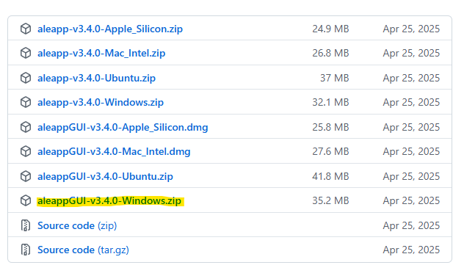

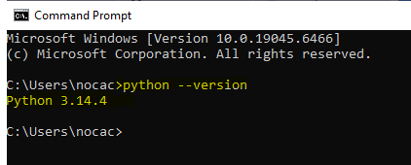

If you do not have python installed or you do not know if it is installed, open cmd.exe and run python --version. If this command returns with anything that is not similar to the above output, install python from here.

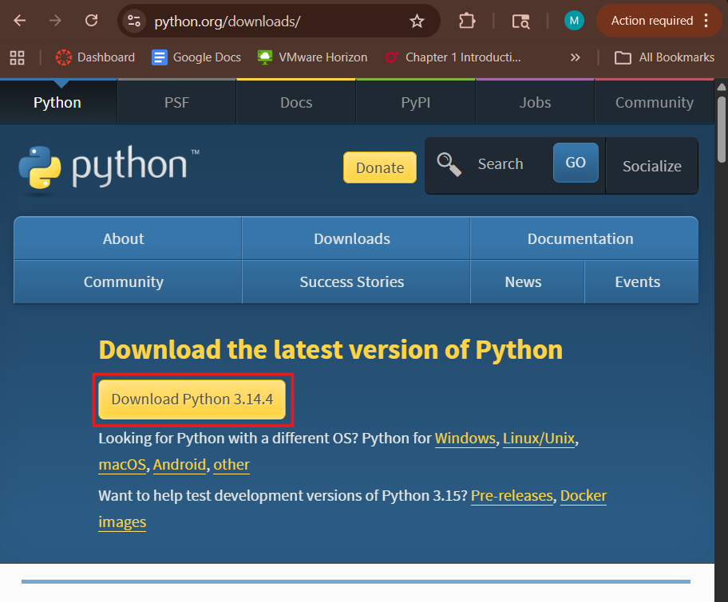
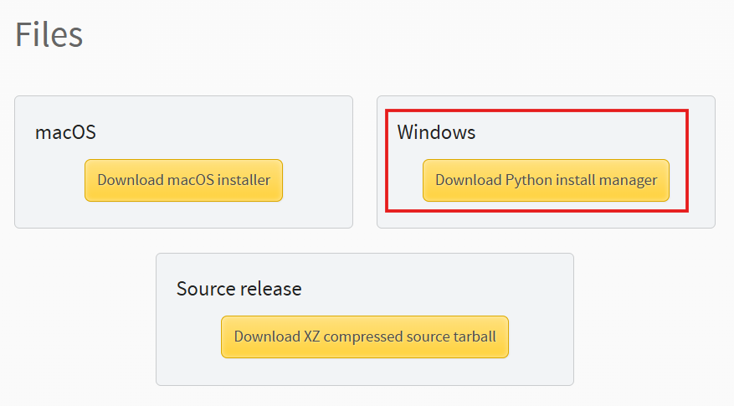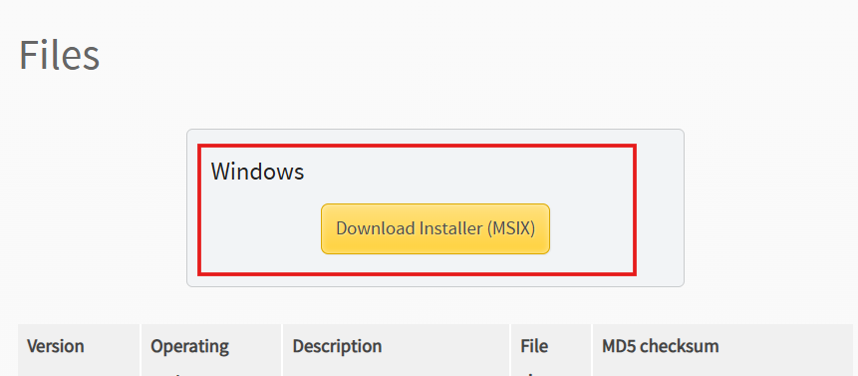
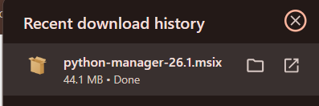
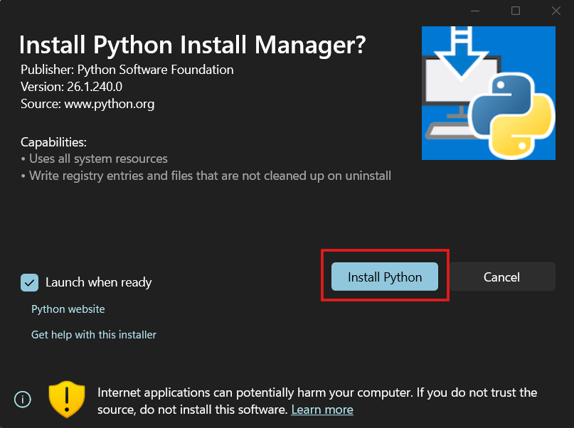
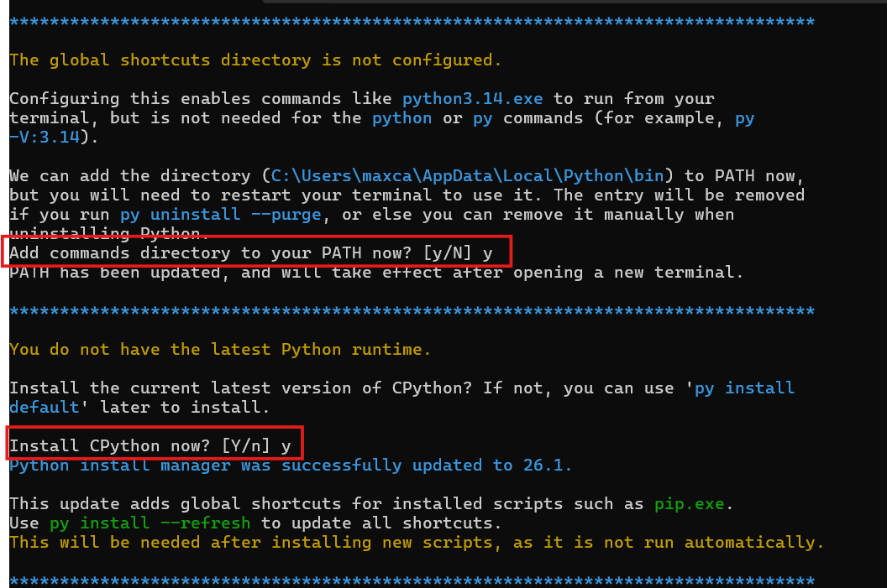
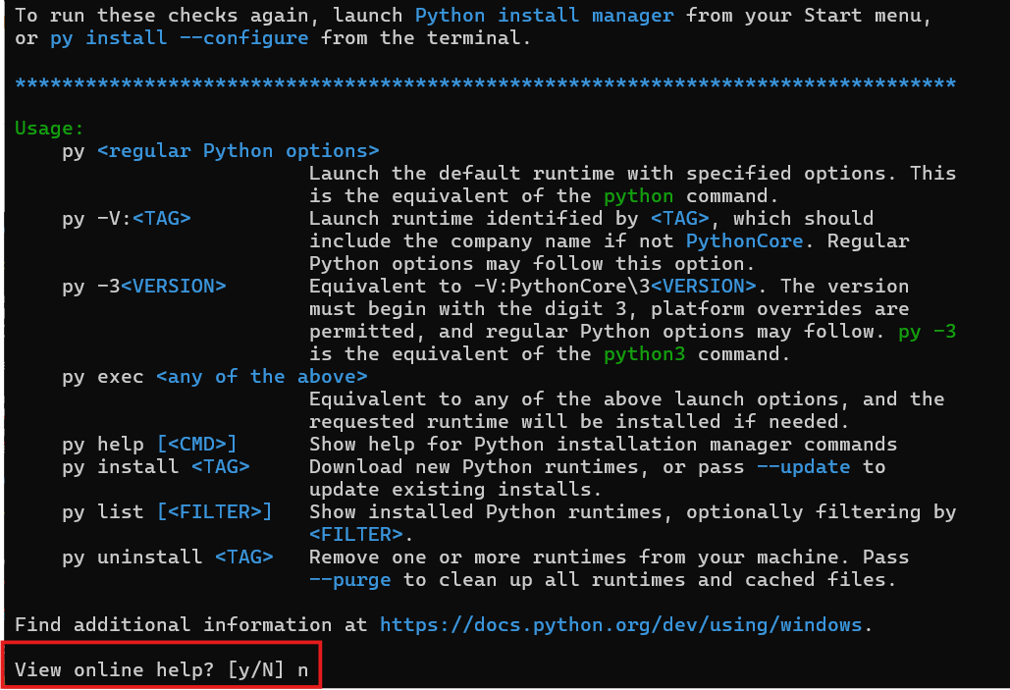
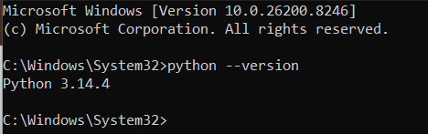

All this does is install python on your device, allowing your computer to access the resources needed to run ALEAPP. As long as you ensure you are installing the version found on the official Python website, there is no need to worry about the installation. When prompted for a yes or no question, answer accordingly. Python should now be downloaded onto your computer.

With our python installation out of the way, ALEAPP should be able to run on your machine. The next step is going to be unzipping and running the application.

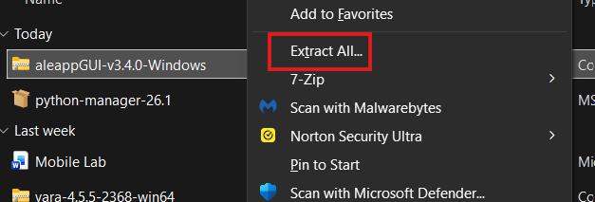
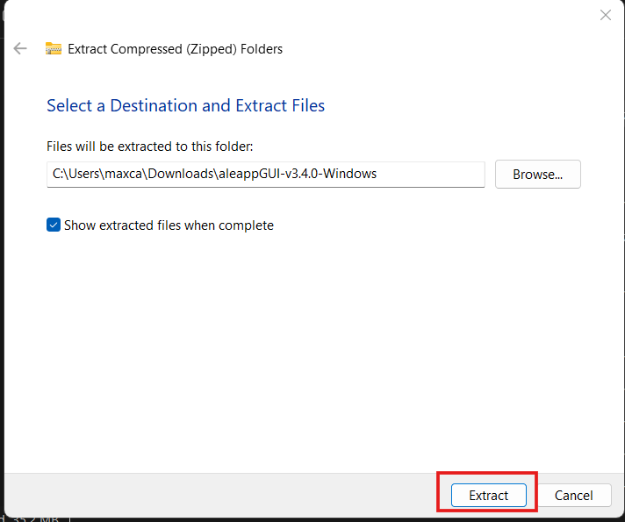
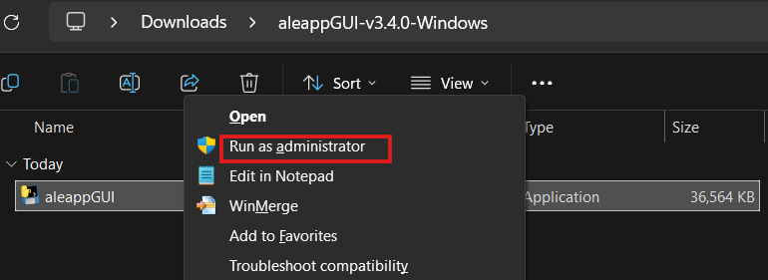
Now that the application is extracted, right click the process and run it as an Administrator to ensure it has proper access to all resources it may require.

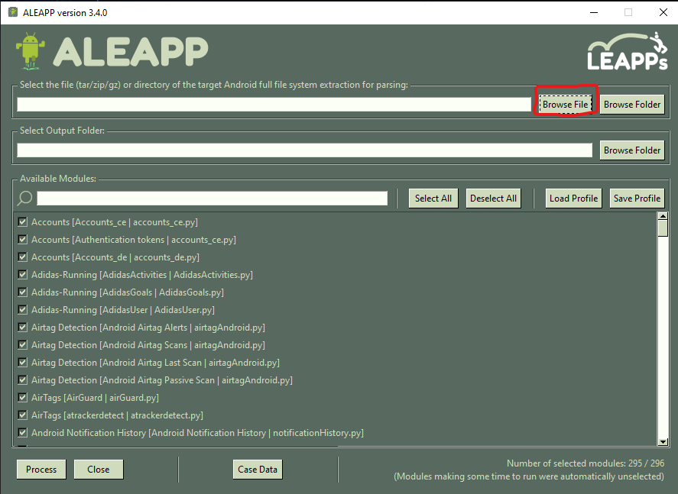
From here, navigate to the tar file of the android filesystem. This is the evidence that will be parsed by ALEAPP.
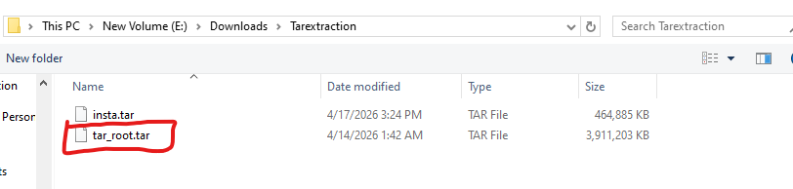

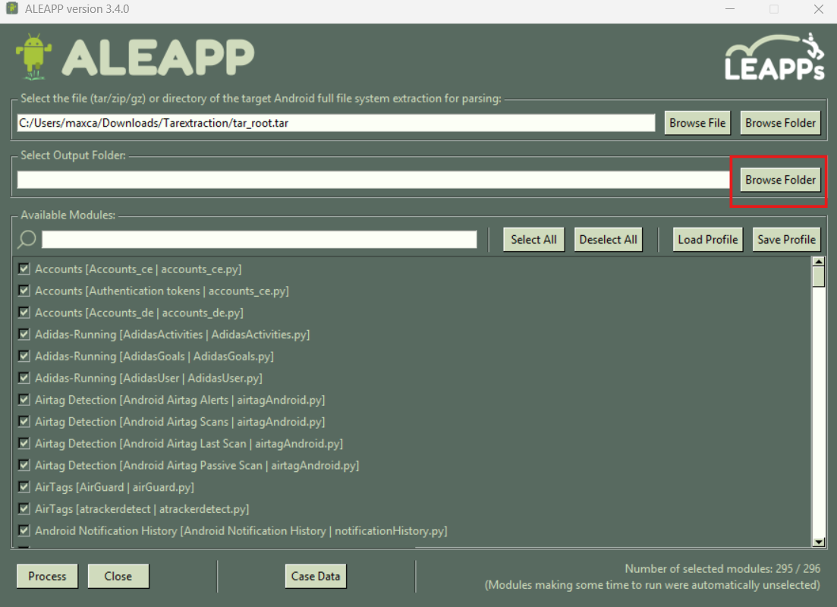
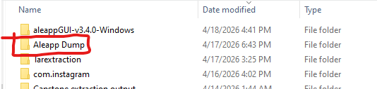
Then select an output folder where we will keep the results of the parsing. ALEAPP will generate a report in html format, allowing the investigator to analyze the report in an easy and lightweight configuration.
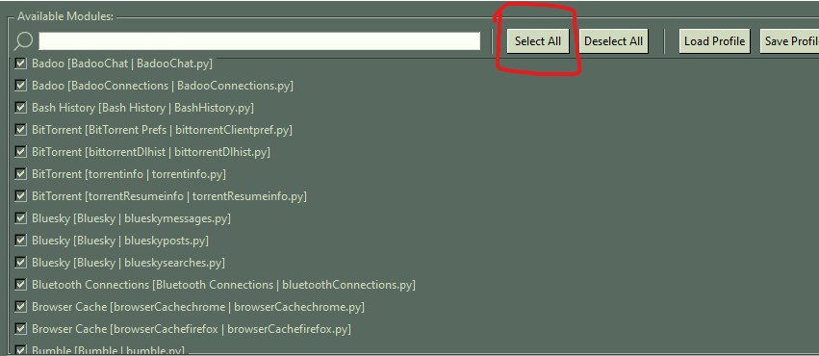
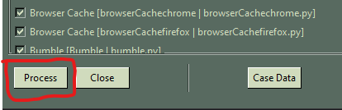
Select all the modules to ensure that no artifacts are lost in parsing. This determines which databases and files ALEAPP will be searching for and compiling. After selecting the modules, run ALEAPP. This will gather our artifacts neatly into a report accessible with your default web browser
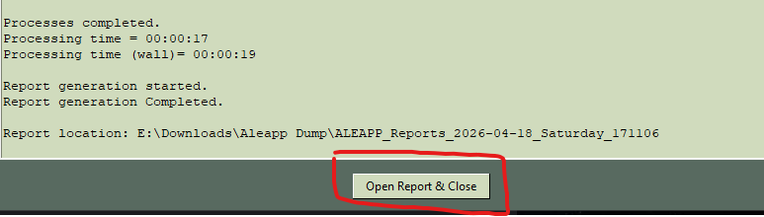
When the processing is complete, open your report and close ALEAPP

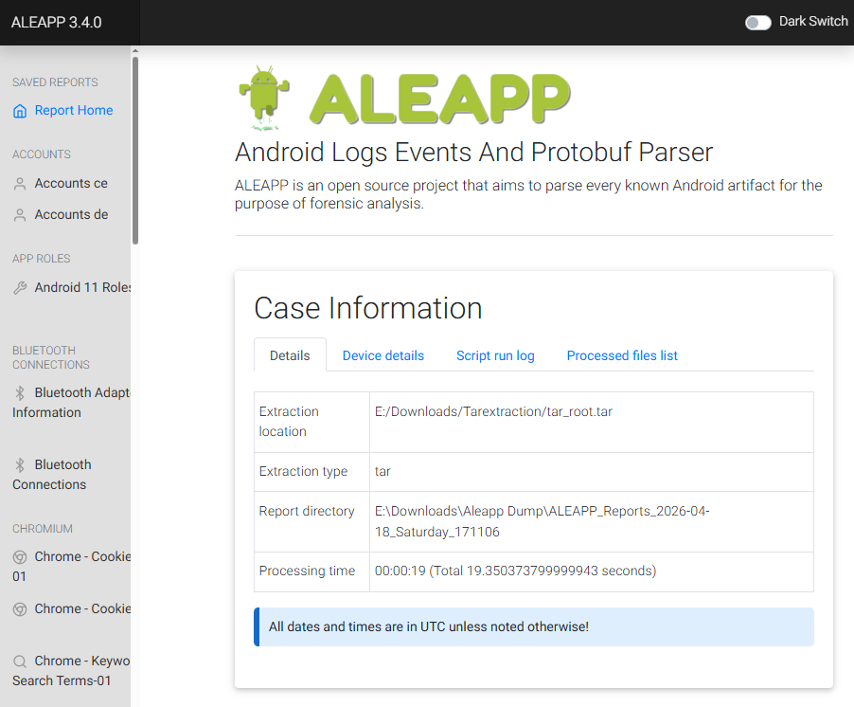
This is what the front page of your report should look like when it is finished. Artifacts will be listed in categories

Task #5: Investigating the Device
Now that we have everything parsed and ready to investigate, we have some questions that need to be answered. Sometimes we need more information than just what happened, we want a character. What was someone doing leading up to the crime? What were their actions? How did they react afterwards? These questions can be found through digital evidence.

Here we will tackle a few questions, mostly relating to text messaging, instagram communication, and google searching. There are a few other artifacts outside of those three but those are the main sources of information. Keep in mind during your investigation the times when things happen. Try to build a timeline to understand the background of these people.

Remember, this lab is meant to be introductory, so if you struggle with any of the questions, there is an attached lab document that contains the answers to these questions. There are certain questions that cannot be answered through just one tool, which is a big part of digital forensics. You will not always have the answers laid in front of you, it is the job of the investigator to determine where to branch out from their tools.

Suspect Questions

- What type of car was Robert showing interest in?

- What motorcycle was Robert doing research on?

- What was Rob's favorite football team?

- What Bills Player did Rob search up on 4/08/2026 around 12am?

- What route is saved in Rob’s google maps?

- Where did Rob eat on 4/08/2026?

- What were the names of the serial killers Rob researched after committing the crime?

Victim Questions

- Where did Dan get lunch on 04/11/26?

- What animal was Dan interested in adopting?

- What funny pictures was Dan searching up on 04/11/26?

- What was the place both Dan and Rob visited on the same day?

- What common interests did Dan and Rob have?

Task #6: Putting it All Together
Now that you have found the answers to these questions, put the pieces together. Please detail below what you determine happened in this case. Make sure to include times and dates when applicable to give a solid timeline of what happened. Remember, your ability to detail the crime will be the deciding factor in this case.

Task #7: Reflection
In this section, reflect on what you learned from the lab. Speak about what you learned about mobile forensics you may have not known before. Do you believe this is a powerful resource for law enforcement? Do you believe that there should be more funding for these sorts of investigations?

